**DAILY ONLINE ACTIVITIES SUMMARY**

|  |  |  |  |  |  |  |  |  |
| --- | --- | --- | --- | --- | --- | --- | --- | --- |
| **Date:** | **19-07-2020** | | | | | **Name:** | **Anix Jugal D’Cunha** | |
| **Sem & Sec** | **8 sem , A sec** | | | | | **USN:** | **4AL16CS013** | |
| **Online Test Summary** | | | | | | | | |
| **Subject** | | **Not Conducted** | | | | | | |
| **Max. Marks** | | **--** | | **Score** | | | **--** | |
| **Certification Course Summary** | | | | | | | | |
| **Course** | **CSS - Basics to Advanced** | | | | | | | |
| **Certificate Provider** | | | **Udemy** | | **Duration** | | | 5 hours |
| **Coding Challenges** | | | | | | | | |
| **Problem Statement:** Java – Boolean to String conversion. | | | | | | | | |
| **Status: Competed** | | | | | | | | |
| **Uploaded the report in Github** | | | | | **yes** | | | |
| **If yes Repository name** | | | | | **alvas-education-foundation/dcunhaanixjugal** | | | |
| **Uploaded the report in slack** | | | | | **yes** | | | |

Online Test Details: (Attach the snapshot and briefly write the report for the same)

**Not Conducted**

Certification Course Details: (Attach the snapshot and briefly write the report for the same)

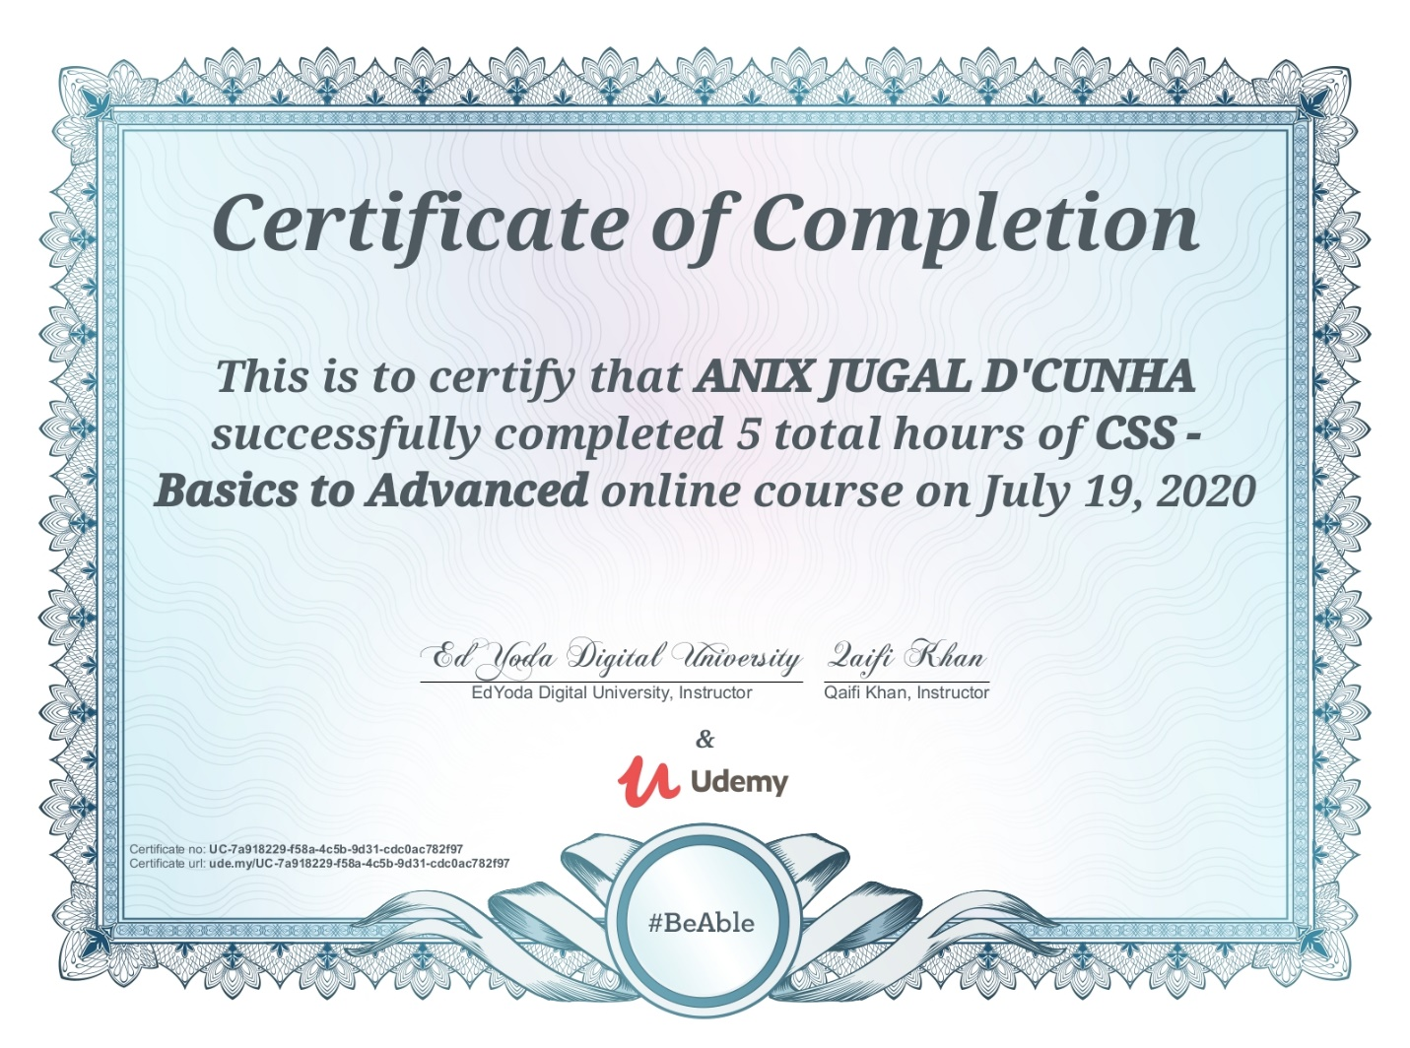

Coding Challenges Details: (Attach the snapshot and briefly write the report for the same)

## Program-> Java – Boolean to String conversion.

|  |
| --- |
|  |

**package com.beginnersbook.string;**

**public class BooleanToString {**

**public static void main(String[] args) {**

**boolean boovar = true;**

**String str = String.valueOf(boovar);**

**System.out.println("String is: "+str);**

**boolean boovar2 = false;**

**String str2 = Boolean.toString(boovar2);**

**System.out.println("String2 is: "+str2);**

**}**

**}**

**Output:**

**String is: true**

**String2 is: false**